Department of Computing

CS344: Web Engineering Class: Spring 2024

# Lab 6: Bootstrap - Personal Portfolio III

# Muhammad Sameer Amjad

# 408160

# BSCS-12B

**Date: March 15, 2024**

**Time: 09:00 to 11:50**

# Instructor: Dr. Farzana Jabeen

**Introduction**

# Lab 6: Bootstrap - Personal Portfolio III

In this lab, Bootstrap framework will be used to upgrade the personal portfolios built in Lab 3. Each student should individually, extend the pages from their own submission to complete this lab.

## Objectives

The objective of this lab is to create a web based personal portfolio with Bootstrap.

## Tools/Software Requirement

* Notepad / MS Word / (or any text editor)
* Google / Bing / DuckDuckGo / (or any preferred search engine)

## Description

In this lab, you will extend your submission from Lab 3. Since that submission only includes HTML and CSS styling elements, you should now further beautify it using bootstrap.

Use atleast 14 distinct components/utilities of bootstrap and add them to a justifiable area of your portfolio. You can increase the number of pages to support this development but make sure the overall design of the portfolio remains consistent.

## Pitfalls

* Failure to upload the solution on LMS.

## Lab Tasks

* Update your submission from Lab 3 of HTML5 + CSS based portfolios and add styling to it using Bootstrap.

**Output:**

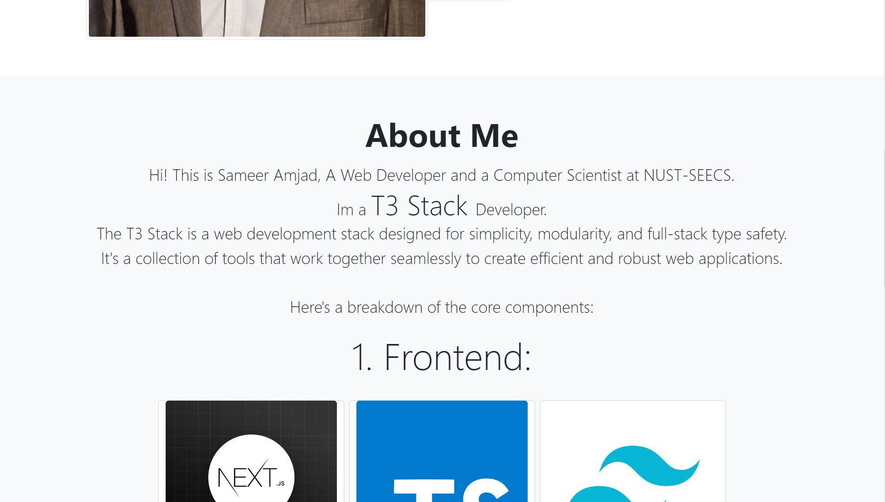

* Use atleast 14 Bootstrap components/utilities.

**Code:**

|  |
| --- |
| <section *class***=**"py-5">          <div *class***=**"container px-5 mt-5 mb-3">              <div *class***=**"row gx-5 align-items-center">                  <div *class***=**"col-lg-6 col-sm-12">                      <img *class***=**"w3 img-fluid object-fit-cover img-thumbnail rounded-3" *src***=**"./assests/IMG_2024.jpg" *alt***=**"..."/>                  </div>                  <div *class***=**"col-lg-6 col-sm mt-xl-0 mt-4">                      <h2 *class***=**"fw-bolder display-3">Muhammad Sameer Amjad</h2>                      <p *class***=**"lead fs-2 fw-normal text-muted mb-0">Computer Scientist | T3 Stack Developer</p>                  </div>              </div>          </div>      </section>  *<!-- about me -->*      <section *class***=**"bg-light py-5">          <div *class***=**"container px-5">              <div *class***=**"row gx-5 justify-content-center">                  <div *class***=**"col-xxl-8">                      <div *class***=**"text-center my-3">                          <h2 *class***=**"display-4 fw-bold mb-3"><span *class***=**"text-gradient d-inline">About Me</span></h2>                      </div>                  </div>              </div>              <p *class***=**"text-center lead px-0 fw-light mb-4 fs-3">Hi! This is Sameer Amjad, A Web Developer and a Computer Scientist at NUST-SEECS. <br> Im a <span *class***=**"lead display-5">T3 Stack </span>Developer.<br> The T3 Stack is a web development stack designed for simplicity, modularity, and full-stack type safety. It's a collection of tools that work together seamlessly to create efficient and robust web applications. <br><br> Here's a breakdown of the core components:</p>                <h3 *class***=**"mt-4 lead display-3 text-center">1. Frontend:</h3>              <div *class***=**"row py-4 justify-content-center">                  <div *class***=**"card mx-1 my-2 d-flex align-items-stretch" *style***=**"width: 20rem;">                      <img *class***=**"card-img-top img-fluid" *src***=**"./assests/nextjs.png" *alt***=**"NEXT.Js">                      <div *class***=**"card-body">                          <h5 *class***=**"card-title">Next.js</h5>                          <p *class***=**"card-text">A popular React framework used for building performant and scalable web applications.</p>                      </div>                  </div>                  <div *class***=**"card mx-1 my-2 d-flex align-items-stretch" *style***=**"width: 20rem;">                      <img *class***=**"card-img-top img-fluid" *src***=**"./assests/typescript.svg" *alt***=**"TypeScript">                      <div *class***=**"card-body">                          <h5 *class***=**"card-title">TypeScript</h5>                          <p *class***=**"card-text">A superset of JavaScript that adds optional static typing, improving code clarity and catching errors early in the development process.</p>                      </div>                  </div>                  <div *class***=**"card mx-1 my-2 d-flex align-items-stretch" *style***=**"width: 20rem;">                      <img *class***=**"card-img-top img-fluid" *src***=**"./assests/tailwind.png" *alt***=**"Tailwind CSS">                      <div *class***=**"card-body">                          <h5 *class***=**"card-title">Tailwind CSS</h5>                          <p *class***=**"card-text">A utility-first CSS framework offering rapid styling with pre-built classes.</p>                      </div>                  </div>              </div>              <h3 *class***=**"mt-4 lead display-3 text-center">2. Backend:</h3>              <div *class***=**"row py-4 justify-content-center">                  <div *class***=**"card mx-1 my-2 d-flex align-items-stretch" *style***=**"width: 20rem;">                      <img *class***=**"card-img-top img-fluid" *src***=**"./assests/prisma.jpg" *alt***=**"NEXT.Js">                      <div *class***=**"card-body">                          <h5 *class***=**"card-title">Prisma</h5>                          <p *class***=**"card-text">A powerful ORM (Object-Relational Mapper) that simplifies interacting with databases using TypeScript.</p>                      </div>                  </div>                  <div *class***=**"card mx-1 my-2 d-flex align-items-stretch" *style***=**"width: 20rem;">                      <img *class***=**"card-img-top img-fluid align-items-center justify-content-center" *src***=**"./assests/trpc.png" *alt***=**"TypeScript">                      <div *class***=**"card-body">                          <h5 *class***=**"card-title">tRPC</h5>                          <p *class***=**"card-text">A type-safe RPC (Remote Procedure Call) framework for creating APIs with clear interfaces and error handling.</p>                      </div>                  </div>                  <div *class***=**"card mx-1 my-2 d-flex align-items-stretch" *style***=**"width: 20rem;">                      <img *class***=**"card-img-top img-fluid" *src***=**"./assests/nextAuth.png" *alt***=**"Tailwind CSS">                      <div *class***=**"card-body">                          <h5 *class***=**"card-title">NextAuth.js</h5>                          <p *class***=**"card-text">An authentication solution for Next.js applications, providing features like social login and JWT authentication.</p>                      </div>                  </div>              </div>          </div>      </section> |

## Deliverables

* Each submission is individual with the following composition:
  + Description document
  + Source Code (Web Pages)
* Convert your submission files into a zip folder and name it as given below, finally upload the zip folder to LMS.
  + Name – Registration No. – Section

**Lab Rubrics:**

|  |  |  |  |  |  |  |  |  |  |
| --- | --- | --- | --- | --- | --- | --- | --- | --- | --- |
| **Code** | **Item** | **Clo** | **Plo** | **Marks** | | | | | |
| **0** | **1** | **2** | **3** | **4** | **5** |
| R1 | Concepts Related to WWW | CLO-1 | PLO-1 | The student is absent in the lab/ The submission is plagiarised. | The student is unable to understand the given problem within the context of WWW and does not select the relevant method to solve it. | Inbetween | The student requires some guidance to  understand the problem, to select relevant method, and to develop appropriate web driven program flow. | Inbetween | The student fully understands the given problem in context of WWW, is able to select the relevant method to solve it. |
| R2 | Modern Solutions | CLO-3 | PLO-5 | The student is absent in the lab/ The submission is plagiarised. | The student is unable to build the website/webapplication using the specified modern tool or framework | Inbetween | The student is trying to use some of the modern tools but is unable to utilize all the appropriate tools or to build the correct solution. | Inbetween | The student is using all the appropriate modern tools to complete the tasks at hand, and provide a modern solution. |
| R3 | Solution Accuracy | CLO-4 | PLO-3 | The student is absent in the lab/ The submission is plagiarised. | The student is unable to produce any part of the solution, with accurate results. | Inbetween | The student is able to produce accurate results for some parts of the solution. | Inbetween | The student is able to produce accurate results for the complete solution. |
| R4 | Ethical development | CLO-5 | PLO-9 | The student is absent in the lab/ The submission is plagiarised. | The student does not demonstrate commitment to professional ethics by following ethical norms applicable to the software industry such as referencing and acknowledgement while using publicly available data/ code. Disturbs the lab environment, doesn’t take care of safety measures, and/or isn’t punctual. | Inbetween | The student partially demonstrates commitment to professional ethics by following ethical norms applicable to the software industry such as referencing and acknowledgement while using publicly available data/ code. Does not disturb the lab environment, takes care of safety measures, and is punctual. | Inbetween | The student clearly demonstrates commitment to professional ethics by following ethical norms applicable to the software industry such as referencing and acknowledgement while using publicly available data/ code. Encourages others to maintain lab decorum, and alerts them to follow safety measures. |